Lucas Swanson
6/1/2026
Software Engineering Methods
Homework 9
Part A: Argoproject - argoproj/argoproj: Common project repo for all Argo Projects
- Using Argo Project as a baseline for a continuous delivery software server architecture, we can easily see how they have implemented both Canary, and Blue Green deployment strategies for the user to select when utilizing their software for customizable rollout strategies listed in the repositories readme and supporting repository used for handling the rollouts.
- Documentation:
Canary - Argo Rollouts - Kubernetes Progressive Delivery Controller
BlueGreen - Argo Rollouts - Kubernetes Progressive Delivery Controller
This shows how Argo handles rollouts and how flexible it can be, allowing the controller to tweak exactly how each rollout is handled either through Canary or BlueGreen strategies.
This is also easily shown in their agro-rollouts support repository: argoproj/argo-rollouts: Progressive Delivery for Kubernetes
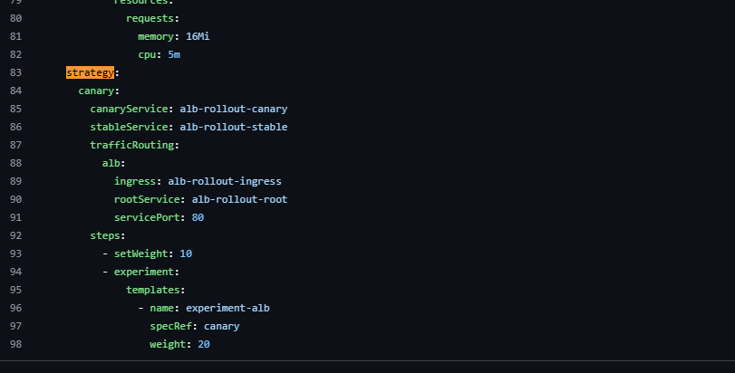
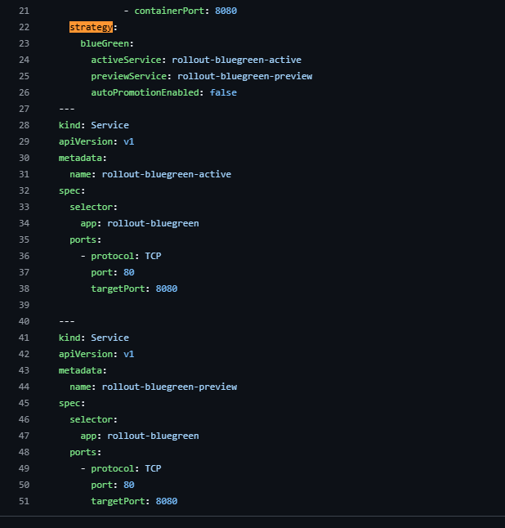
- For this system, I need to make one major assumption: that the basis and premise would be that the development team would need to have access to a good amount of customization and how the server operates to take advantage of the built-in deployment strategies, which rules out Serverless platforms, and some of Platform as a Service.
Scenario:
  - On-Premises:
Team Context: 10 (ish) people, with high levels of deployment experience. Would be required to be On-Call as the website is intended to be operational 24/7. And as hardware is on-site, someone would have to be capable of being present.
Usage profile: Steady, uptime 100% or during working hours (would affect team size), and growth would be slow due to requiring additional hardware, and geographic accessibility is limited to hardware location.
Risk/Compliance Profile: Security would have to be held in house and robust. Further increasing the amount of on-site employment required for all safety regulations that must be performed and upheld within internal company implementation.
Operational Constraints: Budget would be extreme. Requiring teams and physical locations in each geographic region desired to support, with hardware updates as physical units break or wear down and constant maintenance, on-site security and much more.
  - Infrastructure as a Service:
Team Context: 5 (ish) people, with a moderate to high level of deployment experience. On-Call status would still be required, but only software resolution would be required, so on-site is not a must (nor normal).
Usage profile: Can grow faster than On-Premises strategies because if additional bandwidth is required, simply renting additional space is an option, but not automatic.
Risk/Compliance Profile: This requires very little security as the servers are held and maintained by a third party. Although data security would still be the job of the implementers, connections and physical security are held by the rented company.
Operational Constraints: If expansion is required, it is typically simply paid for to the rented company. Expansion is easy as the rented company (such as AWS) already has physical locations and servers maintained in many countries. One constraint would be that almost all server adjustments, customizations, and utilizations would be managed by the implementors through server API’s.

Part B:
Prompt used:
“You are a senior DevOps engineer helping a client select an appropriate CI/CD pipeline.
Analyze the following scenario and create a table detailing the comparison between GitHub Actions, and Jenkins.
Scenario:
Trailcart is a mid-sized, e-commerce system with:
1. A browser-based storefront
2. An API Back end,
3. Checkout workflows
4. Inventory synchronization
5. Periodic promotional campaigns
The team will use this pipeline to release frequently and experience traffic spikes during sales events.
The team has limited DevOps capacity, and needs the system to be maintainable, secure, rollback-friendly, and have an budget deployment workflow.”
GenAI Output:
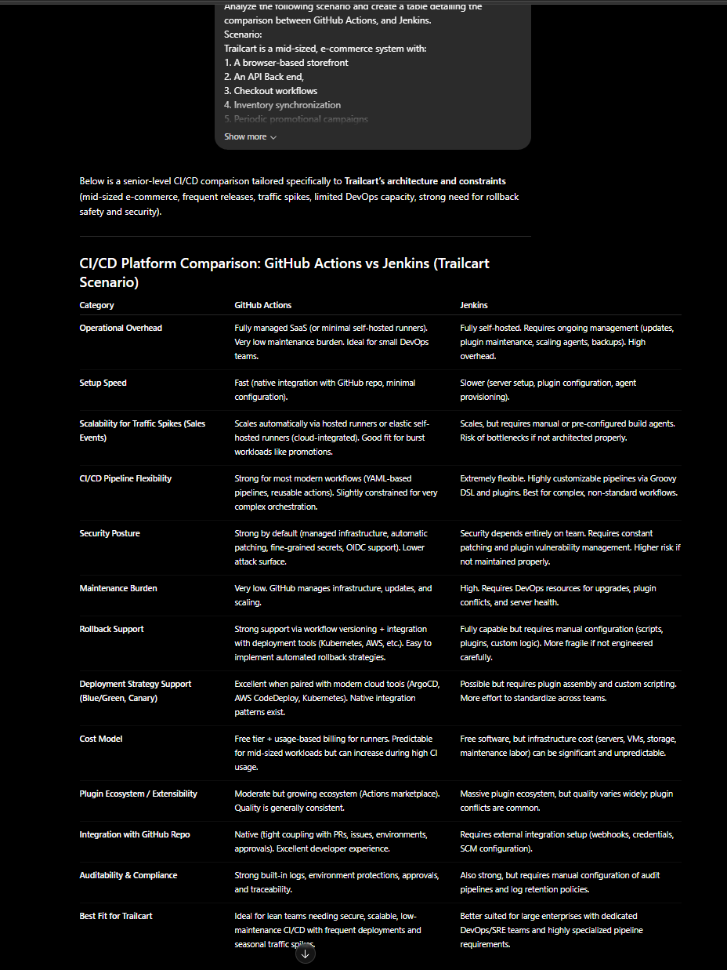
Critique:
I think this matches the Trailcart scenario quite well, as many of the questions from a client’s perspective are already answered without me having to specify what I was looking for. Things such as scalability during traffic spikes, maintenance burden on the client, setup speed, operational overhead required, cost models, and more. These are some of the things I would think about if I were attempting to set up a system quickly and safely. While this table is quite extensive, a few key things are missing. Primarily, the ability to see into any errors or debugging capacity, which is where Jenkins would shine, due to the sheer customizability within the tool, as it can be locally hosted. Another thing to consider is the developer experience required to support each choice, which is where GitHub Actions would shine, as it is a built-in tool for GitHub, where as Jenkins is an internal tool that would be customized by the implementing team. As someone consulting a new or young company, I would warn them about Jenkins requiring some adept DevOps staff. Lastly, I would likely recommend GitHub actions as it seems, based on the scenario, that scalability, maintainability, and security are all big items for the client, and those are where GitHub Actions shines.

Part C:
- Considering the use of Docker for the back-end deployment of SpeedScore, it may be an alright candidate. Firstly the assumption here is that the use of Docker is only for deployment of SpeedScore, and seeing as SpeedScore was originally intended as a solo project created by one person, this is not a bad idea. Some pro’s would be that the mutability of Docker would be quite consistent. Docker is locally operated and would not be subject to much change. But a con for this would be that this would be a huge burden if SpeedScore were ever either to be worked on or fixed by multiple people, or if SpeedScore were to be deployed to multiple servers or regions, as this is a pretty manual process. Any automation would have to be done with some other tool, so scalability is quite low. But as it is a manual process, it would interrupt all usage of the server while updates are happening.
- Pulumi is a much more robust and automatic infrastructure option for implementing the back-end deployment of SpeedScore. This would allow for much more unified server updates rolled out across multiple servers in various areas as it uses methods like Kubernetes which uses a phased deploiyment strategy. This reduces risk to currently operating servers as well as can be applied automatically. This also would allow for users to continue to upload and view their previous results as servers are slowly updated one by one, allowing for seamless usage of the application while updates are happening with no interruptions (slight bandwidth changes while updates are happening). This would also be very scalable and would not modify the infrastructure state as this is most common with IaaS or PaaS.

